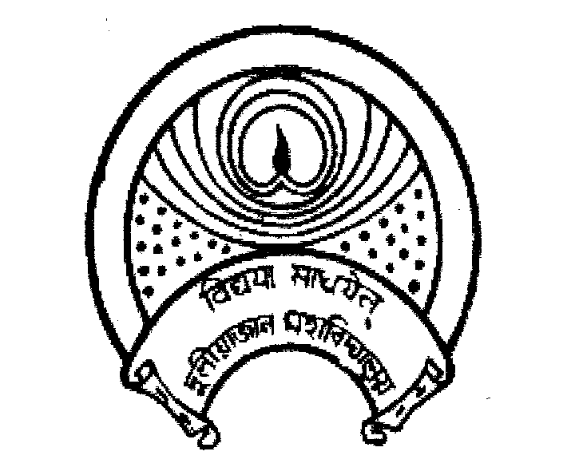
দুলীয়াজান মহাবিদ্যালয়
DULIAJAN COLLEGE
P.O. DULIAJAN – 786 602, Dist. Dibrugarh, Assam.
Phone: 0374-2800356, e-Mail : duliajancollege@yahoo.com, Website : www.duliajancollege.in
NAAC Re-Accreditated Grade B, CGP 2.81
(Registered Under The Societies Registration Act.XXI of 1860)
Registration No. 279 of 1977-78
Under Section 2(F) and 12(B) of the UGC Act, 1956
Ref. No.: DC/PO/Misc./PM Program/2025/222_ Date: 13/09/2025
Notice
In pursuance of the directive received, all teaching staff, non-teaching staff, and students of Duliajan College are hereby informed that the live streaming of the official Centenary Celebration Program of Dr. Bhupen Hazarika, including the Hon’ble Prime Minister’s address scheduled at 5:00 P.M., will be arranged within the college premises.
All concerned are directed to be present compulsorily at the venue to ensure active participation in the program. Necessary arrangements will be made in advance, and the cooperation of every member of the Duliajan College community is earnestly solicited for the smooth execution of this directive.
This matter is of topmost urgency and seriousness, and strict compliance is expected from all.
Venue: Seminar Hall-I
Time: 5:00 P.M. (sharp)
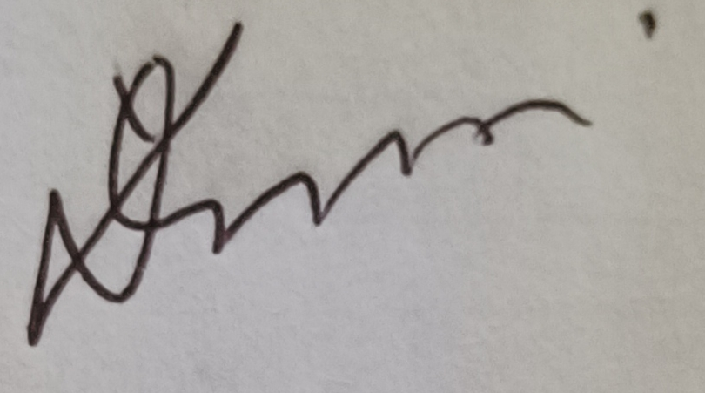
(Dr. Lok Bikash Gogoi)
Principal,
Duliajan College, Duliajan
