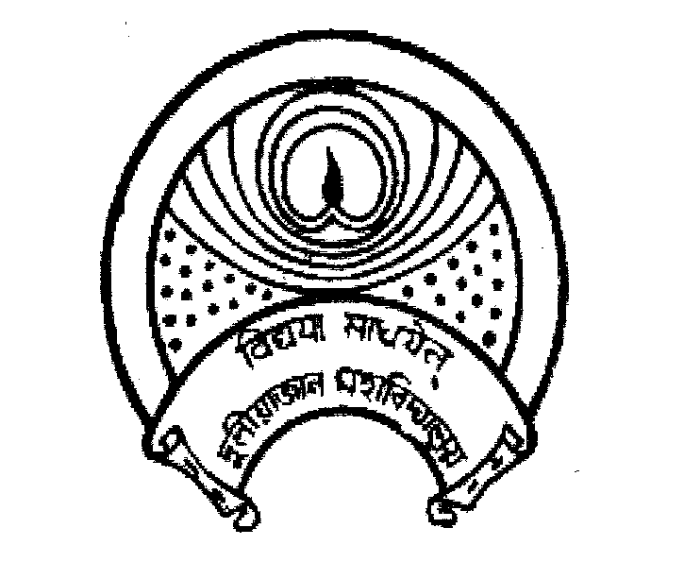
দুলীয়াজান মহাবিদ্যালয়
DULIAJAN COLLEGE
P.O. DULIAJAN – 786 602, Dist. Dibrugarh, Assam.
Phone: 0374-2800356, e-Mail : duliajancollege@yahoo.com, Website : www.duliajancollege.in
NAAC Re-Accredited(3rd Cycle) with B+ Grade
(Registered Under The Societies Registration Act.XXI of 1860)
Registration No. 279 of 1977-78
Under Section 2(F) and 12(B) of the UGC Act, 1956
Ref. No.: DC/PO/Misc./Sessional exam/2025/191 Date: 22/08/2025

Notice

This is to inform all students of Duliajan College that the Unit Test/Sessional examinations will be conducted as per the schedule given below:
- HS 1st and 2nd Year (1st Unit Test) – Commencing from 26th August 2025.
- Degree Classes (1st Sessional Examination) – From 1st September 2025 to 6th September 2025.
All students are hereby directed to prepare accordingly and ensure their presence during the examinations. Detailed routines will be notified shortly.

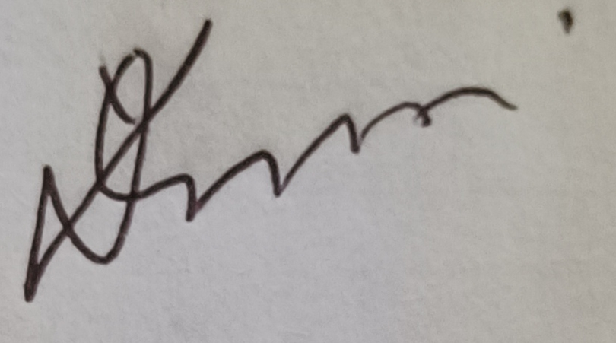
(Dr. Lok Bikash Gogoi)
Principal,
Duliajan College, Duliajan
