DULIAJAN COLLEGE
P.O. DULIAJAN – 786602
Dist. Dibrugarh (Assam)
(Registered Under The Societies Registration Act. XXI of 1860)
Registration No. 279 of 1977-78
Under Section 2(F) and 12(B) of the UGC Act, 1956
Website: www.duliajancollege.in Email: duliajancollege@yahoo.com
OFFICE OF THE I.Q.A.C.
Email: iqacduliajancollege@gmail.com

Ref. No. DC/IQAC/2022/30 Date: 24.09.2022

NOTIFICATION

The students and student guardians of Duliajan College are hereby directed to submit their feedback as per the format given through the Google forms for the academic year 2021-22 immediately. That the links for the feedback forms are attached herewith.

1) Students' Feedback
https://forms.gle/VqdZGbhNq7Hcjg279

2) Guardian's Feedback
https://forms.gle/LKALMRfB5AcbG2HZ6

3) Feedback on Teachers
https://forms.gle/yZ7H8BTzdmUX5RDn8

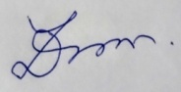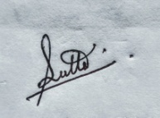

(Dr. Lok Bikash Gogoi) (Dr. Dayananda Nath) (Prof. Jayanta Dutta)
Principal Jt. Coordinator Jt. Coordinator
Duliajan College I.Q.A.C., Duliajan College I.Q.A.C., Duliajan College

