Department Teachers and Students Meeting
Agenda:-
- 1st Semester End Semester Results Feedback
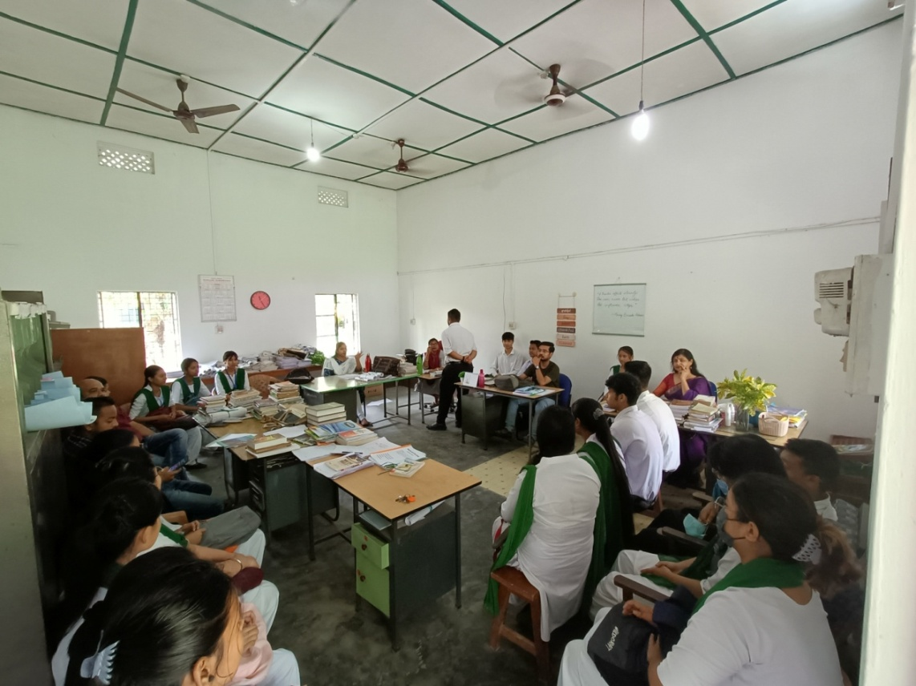
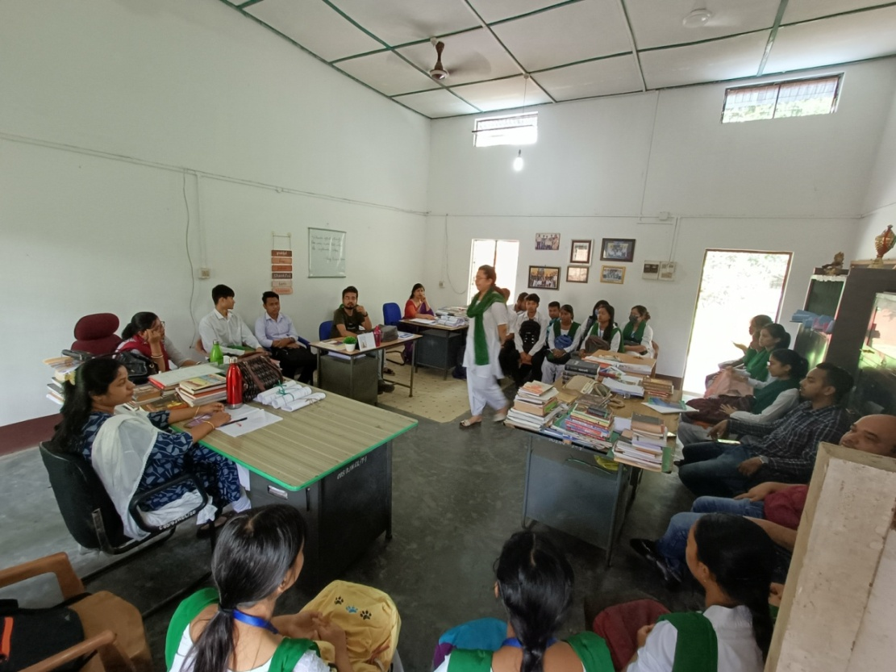
- Discussion on DiscourseZ: Department Journal

